Virtual Institutes for Cyber and Electromagnetic Spectrum Research and Employ (VICEROY)
DoD Electromagnetic and Cyber Research and Experiential Education (DECREE) Virtual Institution
VICEROY DECREE VIRTUAL INSTITUTE Scholarship Program 2024
Kennesaw State University is seeking applications from current undergraduate students to join our inaugural cohort of VICEROY DECREE scholars. The Virtual Institutes for Cyber and Electromagnetic Spectrum Research and Employ (VICEROY) DoD Electromagnetic and Cyber Research and Experiential Education Virtual Institute (DECREE) is a consortium of universities created in close collaboration with the Department of Defense (DoD) and Defense Information Base partners to address recruitment and training challenges faced in DoD-related Cybersecurity and Electromagnetic Spectrum (EMS) fields. The goal of the program is to grow the availability of well-qualified and trained students with essential knowledge, skills, and abilities required to plan, synchronize, and lead DoD-related cyber and EMS operations. VICEROY DECREE scholars will receive a scholarship funding, for up to 15 in-state credit hours/semesters for two semesters, plus a stipend for books, to participate in a virtual curriculum focused on cybersecurity, data science, applied mathematics and cryptography, and strategic foreign languages offered by a consortium of VICEROY partner institutions including North Carolina A&T State University, Auburn University, Tuskegee University, and Kennesaw State University. Scholars will be eligible to take virtual, credit-bearing coursework from consortium institutions, have access to mentoring programs, as well as access to DoD-related internships, co-ops, and post-graduation employment opportunities.
Scholars will be required to complete 12 credits, of which at least half are experiential in nature (i.e., two courses), within the VICEROY DECREE designated curriculum by the end of the FALL 2024 semester.
Eligibility Criteria: VICEROY DECREE scholarships will be awarded to students selected by the KSU VICEROY scholarship committee.
Applicant must:
- Be a current full-time junior or senior and complete the program requirements by June 2025, with a current GPA of at least 3.0.
- Be enrolled in one of the VICEROY related fields (cyber/information security, data science, applied mathematics and cryptography, or strategic foreign languages).
- Be security clearance eligible.
- Intend to pursue employment within DoD or the defense industry.
Expectations of scholars:
- Will complete at least 12 credits of VI-designated courses during the scholarship period.
- Will participate in all mandated VICEROY-related events, including but not limited to professional development sessions, mentoring meetings, and symposiums.

Priority will be given to:
- Members of underrepresented groups.
- Current ROTC students NOT on scholarship.
- Active/reserve military and veterans.
- Cybersecurity Majors/Minors.
- Seniors with at least two full semesters remaining (Spring/Fall 2024).
Application Components: All requirements below must be submitted to be considered by the scholarship committee:
- Signed and dated application form (end of this document).
- A 1-page single-spaced essay indicating why the applicant feels they are qualified for this scholarship and what their goal is upon graduation, regarding DoD/ DoD partner/Government employment. Should be single-spaced and written on the final page of this document.
- Letter of Recommendation from a Professor, Supervisor, or Commander, that can speak to your skills and potential in DoD-related cybersecurity and electromagnetic spectrum operations.
- A resume that emphasizes any academic honors, awards, community service activities, athletics, military/ROTC service, extracurricular activities, and/or leadership positions held, if applicable.
- An unofficial transcript (OwlExpress/DegreeWorks PDF is acceptable).
Applications must be emailed as a single PDF document attachment to cybersec@kennesaw.edu and received no later than midnight, Wednesday, November 22, 2023. Selectees will be notified by Wednesday, December 1, and provided with instructions. Selectees will be expected to sign an agreement indicating compliance with the requirements of the scholarship. Failure to comply with the requirements will result in a discontinuation of the scholarship, and possibly a requirement for restitution.

Selected scholars must structure their required 12 credit hours to comply with one of the following certification tracks. The indicated core courses are required for the track, but students may select from ANY of the electives listed in their track. For strategic foreign languages, 4-5 courses are needed to complete the certificate.
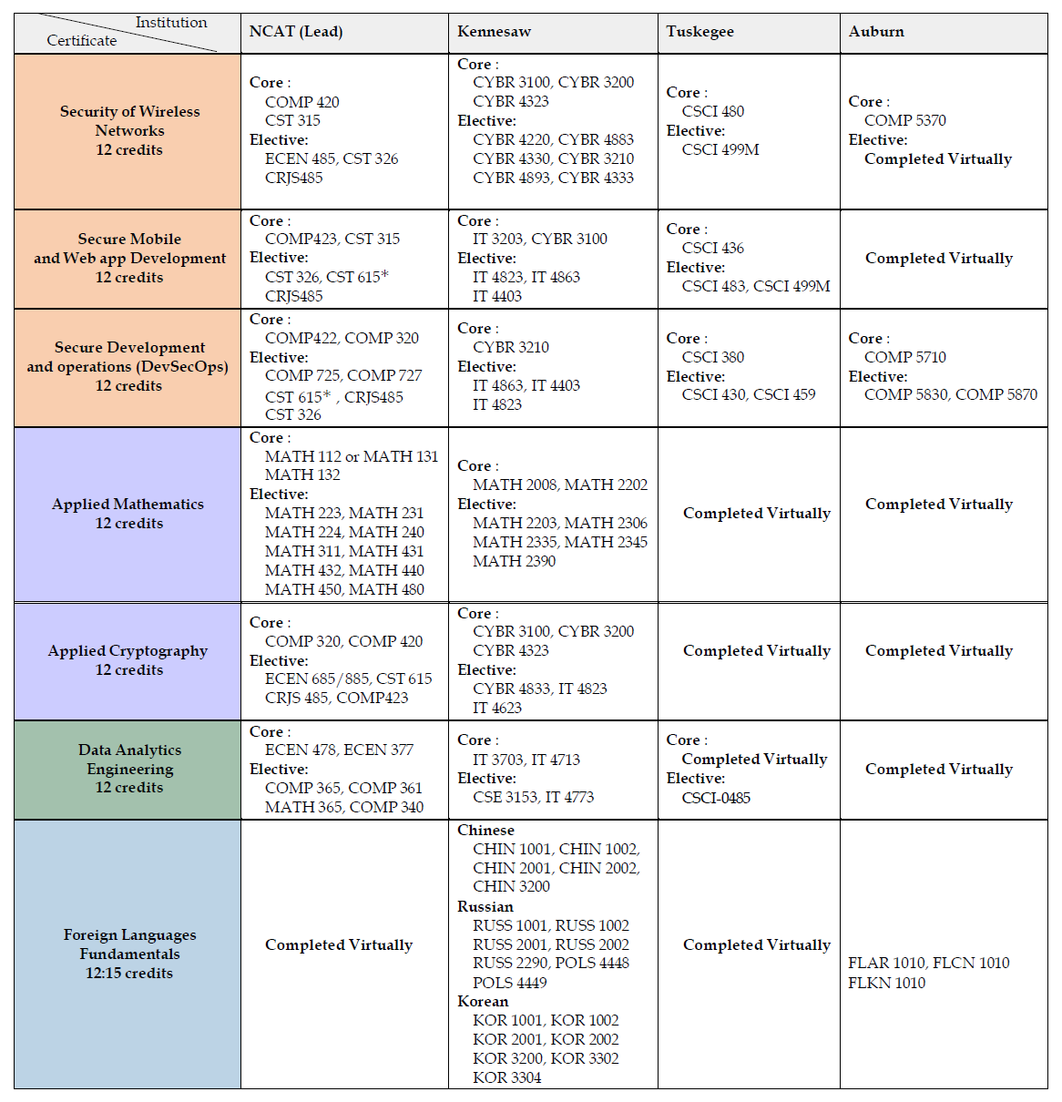
Virtual Institutes for Cyber and Electromagnetic Spectrum Research and Employ (VICEROY)
DoD Electromagnetic and Cyber Research and Experiential Education (DECREE) Virtual Institution

Full Legal Name:
KSU Email address:
KSU NetID:
KSU ID Number:
KSU major and/or minor:
Anticipated graduation date (month/year):
Are you a member of an underrepresented group? _____ Yes _____ No
Please elaborate:
Are you a member of ROTC? _____ Yes _____ No On ROTC Scholarship? _____ Yes _____ No
Which Branch?
Are you active-duty military, reservist, and/or veteran? _____ Yes _____ No
Briefly describe:
Indicate the semester(s) which you plan to take your VI certificate courses (non-binding, 12 credits):
_____ Spring 2024 _____ Fall 2024 (note: if you have already taken one or more courses from your chosen certificate track, simply highlight those in your included transcript).
Essay: On the next page, please explain why you feel you are best qualified for this scholarship, and what your employment goals are upon graduation for the DoD/DoD Partner/U.S. Government.

STATEMENT OF ACCURACY
I hereby affirm that all the above-mentioned information provided by me is true and correct to the best of my knowledge. I also consent that my picture may be taken and used for any purpose deemed necessary to promote the VICEROY DECREE Scholarship Program. I hereby understand that if chosen as a scholarship awardee, I must provide evidence of full-time enrollment/registration at my home institution before scholarship funds can be awarded.
Signed: __________________________ Date: ______________________
Applications will be accepted on a rolling basis. The priority deadline is November 22, 2023.
Email all application materials as a single PDF document organized in the following order to cybersec@kennesaw.edu. Include the term “VICEROY SCHOLARSHIP” in the subject line.
Document and order:
1. Signed and dated application form (this document). Please delete instructions pages before submission. This should be the first page.
2. 1-page single-spaced essay. (Single spaced, using the next page only.)
3. Letter of Recommendation.
4. Resume emphasizing honors, awards, community service, athletics, military/ROTC service, extracurricular activities, and/or leadership positions held, if applicable.
5. Unofficial transcript (OwlExpress/DegreeWorks PDF is acceptable).
Essay (single spaced, using this page only):
Please explain why you feel you are best qualified for this scholarship, and what your employment goals are upon graduation for the DoD/DoD Partner/U.S. Government.

