Anja Bernardy (SAMPLE 3)
Creating a Midterm Course Evaluation Survey in D2L
RCHSS Student Success Summit
May 12, 2025
SPAN 2001 (hybrid) Midterm Course Evaluation Survey Questions
Ordering Question (ORD):
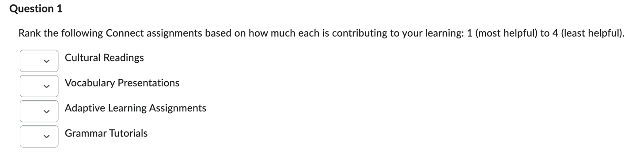
Short Answer Question (SA):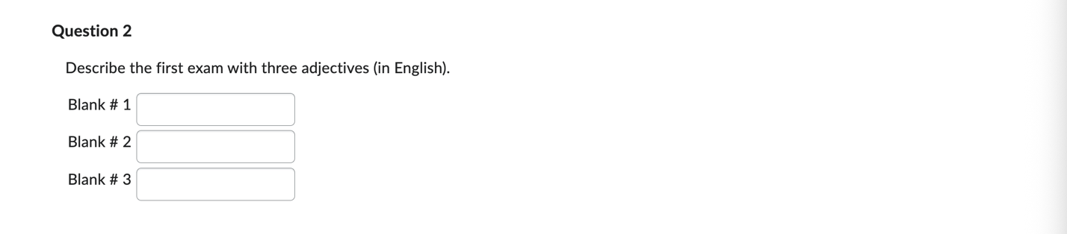Written Response (WR):
